Jaypee Institute of Information Technology
Sector 62



Cloud and Web Services Lab [17M15CS121]
Project Synopsis
Title: “Cloud-Based Medical Appointment System”
Submitted To:-
Dr. Anil Kumar Mahto
Assistant Professor (Senior Grade)
Dept. Of CSE
JIIT SECTOR 62,NOIDA

TEAM MEMBERS

Name | Enrollment No. | Batch
SABEEH AHSAN | 22803006 | B12
HARLEEN KAUR | 22803009 | B12
ARYAN KHANNA | 22803028 | B12

PROJECT OUTLINE

S.NO | TITLE | PAGE  NO
1 | PROBLEM STATEMENT | 4
2 | OBJECTIVES | 5
3 | FLOWCHART | 6
4 | IMPLEMENTATION DETAILS | 7
5 | TOOLS USED | 8
6 | EXPECTED OUTCOMES | 9
7 | REFERENCES | 9

PROBLEM STATEMENT

In the healthcare sector, patients often face difficulties in finding suitable doctors, booking appointments, and maintaining medical records efficiently. Traditional appointment booking methods involve manual processes, long waiting times, and poor record management. Additionally, patients may find it difficult to access prescriptions and appointment history when needed.

The proposed Cloud-Based Medical Appointment System aims to provide a centralized web-based platform that allows patients to search for doctors, book appointments, upload and access prescriptions, and maintain appointment records securely. The system leverages cloud technologies to ensure scalability, availability, and secure storage of healthcare data.

OBJECTIVES

We have considered below objectives for our project:

- To develop a cloud-based platform for online appointment scheduling.
- To provide secure patient and doctor registration and authentication.
- To enable patients to search doctors based on specialization and availability.
- To facilitate online appointment booking and management.
- To securely store prescriptions and medical reports in cloud storage.
- To maintain appointment history and healthcare records digitally.
- To implement RESTful APIs for communication between frontend and backend services.
To deploy the application on cloud infrastructure for improved accessibility and scalability.

FLOWCHART

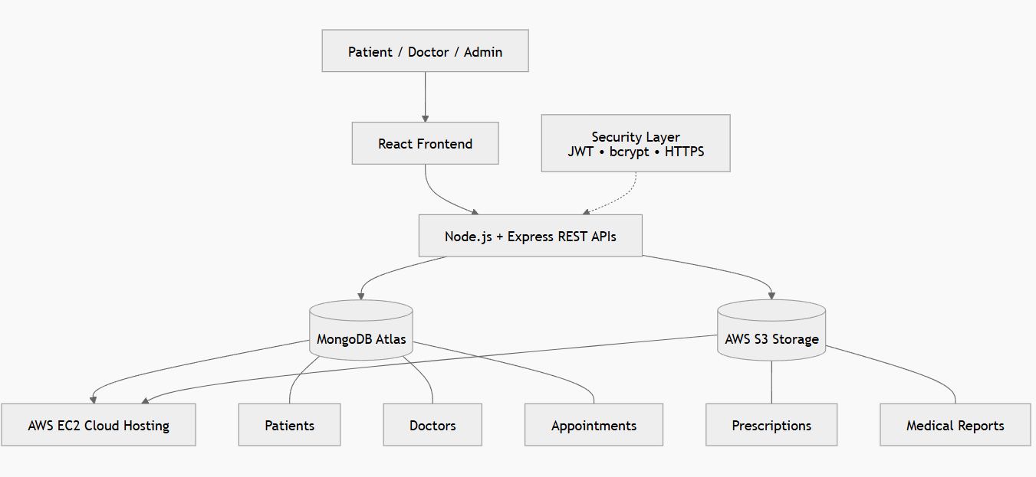

Above Figure explains the workflow of our Cloud Based Medical Appointment System. It uses React for the frontend, Node.js and Express for REST APIs, MongoDB Atlas for storing patient, doctor, and appointment data, AWS S3 for prescription storage, and AWS EC2 for cloud deployment, while JWT, bcrypt, and HTTPS provide secure authentication and communication.

IMPLEMENTATION DETAILS

The system follows a three-tier cloud architecture consisting of a frontend, backend, and database + cloud storage services.

Step 1: User Authentication

Patients and doctors register and log in using secure credentials.

JWT-based authentication is used for secure access.

Step 2: Doctor Search

Patients search doctors by specialization, experience, or availability.

Doctor information is retrieved from the database using REST APIs.

Step 3: Appointment Booking

Patients select a doctor, date, and available time slot.

Appointment details are stored in the database.

Step 4: Appointment Management

Doctors can approve, reject, or reschedule appointments.

Patients receive updated appointment status.

Step 5: Prescription Upload

Doctors upload prescriptions and medical reports.

Files are stored securely in AWS S3 cloud storage.

Step 6: Appointment History

Patients can view previous appointments and prescriptions.

Data is retrieved from MongoDB.

TOOLS USED

Frontend

React.js

HTML

CSS

JavaScript

Backend

Node.js

Express.js

Database

MongoDB Atlas

Cloud Services

AWS EC2

AWS S3

Security

JWT Authentication

bcrypt Password Hashing

Development Tools

Visual Studio Code

GitHub

EXPECTED OUTCOMES

The outcomes expected to be achieved after developing this project are:

A fully functional cloud-based medical appointment platform.

Easy doctor discovery and online appointment booking.

Secure storage and retrieval of prescriptions and medical records.

Reduced manual effort in appointment scheduling.

Centralized healthcare record management.

Practical implementation of cloud computing, REST APIs, database integration, and authentication concepts.

Scalable and reliable healthcare service accessible from any location.

REFERENCES
- React Documentation – https://react.dev
- Node.js Documentation – https://nodejs.org
- Express.js Documentation – https://expressjs.com
- MongoDB Documentation – https://www.mongodb.com/docs
- AWS EC2 Documentation – https://docs.aws.amazon.com/ec2
- AWS S3 Documentation – https://docs.aws.amazon.com/s3
- JWT Documentation – https://jwt.io
- REST API Tutorial – https://restfulapi.net

